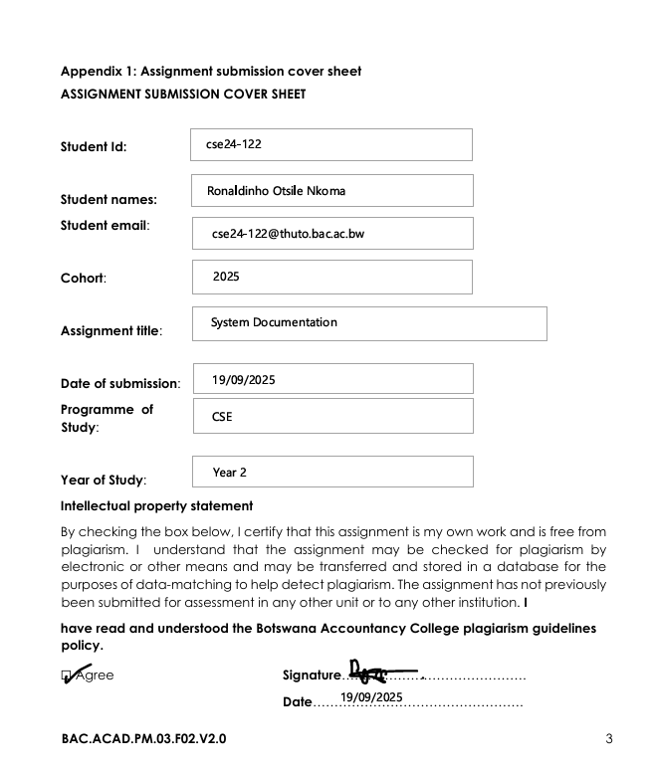

SYSTEM DOCUMENTATION

Requirement elicitation

*Functional requirements*

**1: Create Customer Profile.** The system must allow the creation of a new customer profile with the following mandatory fields: First Name, Surname, National ID Number, and Physical Address. Phone number is optional.

**2: Enforce Unique National ID.** The system must ensure that each customer's National ID number is unique and prevent duplication.

3: **Open Savings Account**. The system must allow a bank officer to open a Savings Account for a customer.

4: **Open Investment Account.** The system must allow a bank officer to open an Investment Account only if the initial deposit is exactly BWP 500.00 or more. If the amount is less, the transaction must be rejected and the account must not be created.

5: **Open Cheque Account**. The system must allow a bank officer to open a Cheque Account only if the customer provides employer details (employer name and company address). The system must prevent account creation if these details are missing.

6: **Support Multiple Accounts**. A single customer must be able to hold one or more accounts of any type (e.g., a Savings, an Investment, and a Cheque account).

**7: Process Deposits.** The system must allow deposits to be made to any account type (Savings, Investment, Cheque).

**8: Process Withdrawals from Investment Account.** The system must allow withdrawals from an Investment Account *only* if the transaction would not bring the balance below zero. It must reject any withdrawal that would result in a negative balance.

**9: Process Withdrawals from Cheque Account.** The system must allow withdrawals from a Cheque Account (implied, as it's used for salaries and allows withdrawals of "any amount").

**10: Prevent Partial Withdrawals from Savings Account.** The system must **not** allow any partial withdrawals from a Savings Account.

**11: Close Savings Account.** The system must provide a formal "closure" process for a Savings Account, authorized by a bank officer, which facilitates a withdrawal of the **entire balance plus accrued interest**, effectively closing the account.

**12: Calculate Interest Monthly.** The system must provide an administrative function (e.g., a "Calculate Monthly Interest" button) to trigger interest calculation.

**13: Apply Correct Interest Rates.** The interest calculation process must apply a 0.05% monthly interest to all Savings Accounts and a 5% monthly interest to all Investment Accounts.

**14: Display Customer and Account List.** The system must be able to display a list of all customers and their associated account types.

**15: Update Customer Information.** The system must allow bank officers to update and modify customer information (e.g., address, phone number) in the system.

*Non-Functional requirements*

**1. Usability**

**Modern User Interface (UI).** The system must have a modern, intuitive design that aligns with current design trends to ensure user satisfaction and ease of use.

**Clear Interaction.** The system must interact with the user without any miscommunications. This implies clear error messages, confirmations, and a logical workflow.

**2. Performance**

**Response Time.** The system must have a very fast response time, with a target of approximately **3 milliseconds** for operations like updating balances or searching for customers. (Note: This is an extremely aggressive target and may need to be clarified or negotiated).

**3. Reliability & Accuracy**

**Data Validation.** The system must reliably enforce all business rules (e.g., minimum deposit for Investment account, no withdrawals from Savings) without failure to ensure data and transactional integrity.

**Batch Processing Reliability.** The monthly interest calculation batch job must run accurately against all eligible accounts without missing any or applying incorrect calculations.

**4. Security**

**Authorization.** The system must ensure that certain functions (like calculating interest or closing accounts) are only performed by authorized bank officers/administrators.

Structural modelling

Use case diagram

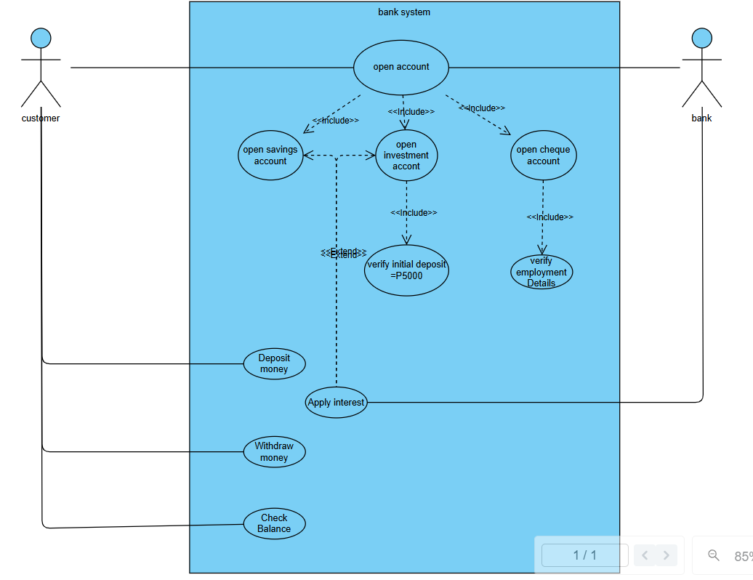

Class diagram

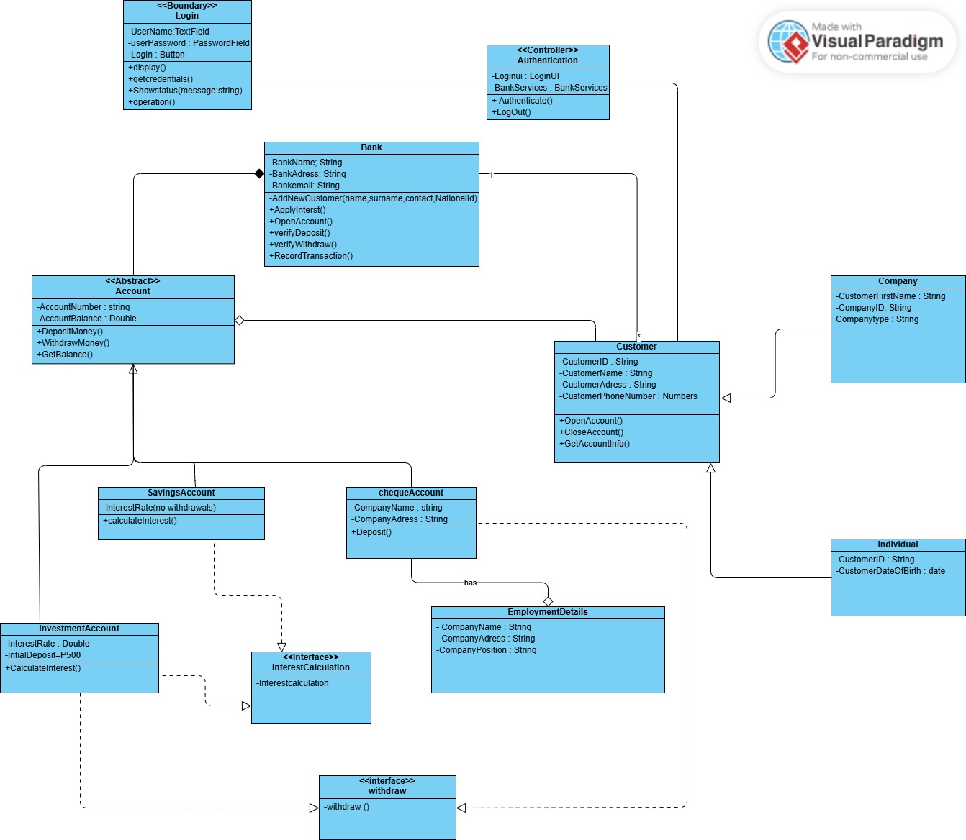

Behavioural Diagrams

Sequence diagram

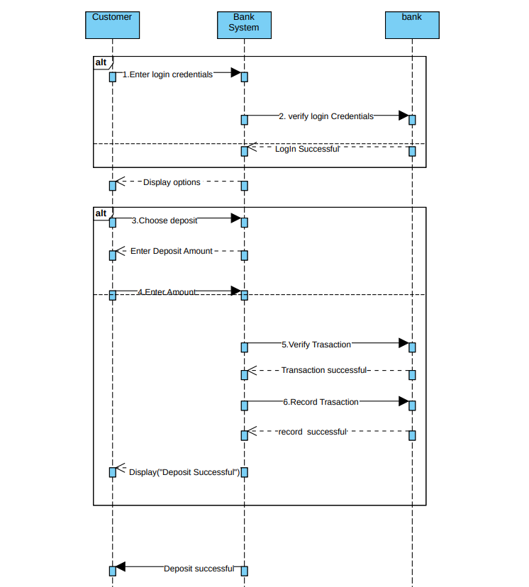

State diagram

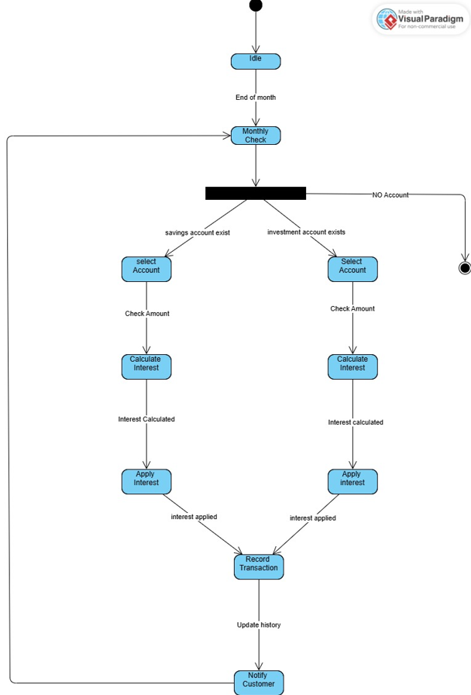

Interview record

Interviewer: Ronaldinho Nkoma, Computer engineering student

Interviewee (Client) MR Temba Moeba, Lecturer

Date: September 17, 2024

Purpose: To clarify the initial project brief and elicit detailed functional requirements for the new Banking System.

Interview Transcript :

Interviewer: "Thank you for your time, Mr. THEMBA MOENG. The brief mentions three account types. For the Cheque Account, could you clarify what 'working' means? Does a student with a part-time job qualify?"

Mr. TM: "Good question. For our purposes, 'working' means the customer must be employed and receive a regular salary. A student with a part-time job would qualify, but we must capture their employer's details for our records. The system must prevent us from opening this account type if these details are missing."

Interviewer: "Understood. Regarding the Investment Account, the brief states it requires BWP 500.00 to open. Should the system prevent its creation if the initial deposit is less than that?"

Mr. TM: "Absolutely. It's a hard rule. The transaction should be rejected, and the account should not be created. The same goes for any withdrawal that would bring the balance below zero. We don't offer overdrafts on investment products."

Interviewer: "What about the Savings Account? The brief says 'does not allow any withdrawals.' Is this a permanent lock? What if the customer wants to close the account to get their money?"

Mr. TM: "Another excellent point. 'No withdrawals' refers to partial withdrawals. The entire point is to lock the funds to encourage saving. The only way to get the money out is to formally close the entire account, which would involve a bank officer authorizing a final withdrawal of the entire balance plus any accrued interest. The system should allow this closure process."

Interviewer: "Noted. The system needs to calculate interest monthly. How should this be triggered? Is it an automatic process run on the last day of the month?"

Mr. TM: "Yes, it should be an automated background process. For this initial version, we can assume a bank administrator will press a 'Calculate Monthly Interest' button. This action should apply the correct interest to every eligible account in the system in one go."

Interviewer: "Finally, what information is absolutely critical for a new customer?"

Mr. TM: "We need to be able to identify and contact them. The minimum is: First Name, Surname, National ID Number, and Physical Address. A phone number is highly preferred but not mandatory for system creation. The National ID must be unique in the system."

Interviewer : “What do you think should be the appropriate response time of the system ?”

Mr TM : “The appropriate response time of the system should range from 3 milliseconds.”

Interviewer : “what are any other key features do you think the system should do that i may have overlooked?”

Mr TM : “The system should be able to display a list of the customers and their account types , so as to update information of the customers in the system by the bank . The system should also be design to keep up with the design trends of todays generation and interact with the user without any miscommunications.”

Interviewer : "Thank you, Mr. Themba Moeng. This has been very clarifying."

Mr. TM:"You're welcome. Please ensure the system is built with these rules firmly in place."